AVIATION MANAGEMENT SYSTEM
A Project Report
Submitted with partial fulfillment of the requirement for the
Award of degree (MCA)
2016-2019

Submitted by: Guided by:
Rohit Sharma Mr. Pankaj Kumar



BHARATI VIDYAPEETH DEEMED UNIVERSITY SCHOOL OF DISTANCE EDUCATION
Academic Study Center- BVIMR , New Delhi
An ISO 9001:2008 Certified Institute
NAAC Accredited Grade “A””

Student Undertaking
Certificate of Originality

I Rohit Sharma, MCA VI. I would like to declare that the project report entitled Contacts Manager is Submitted to Bharati Vidyapeeth University Pune, School of Distance Education Pune, Academic Study Centre BVIMR New Delhi in partial fulfilment of the requirement for the award of the degree.
It is an original work carried out by me under the guidance of Mr. Pankaj Kumar.
All respected guides, faculty member and other sources have been properly acknowledged and the report
contains no plagiarism.
To the best of my knowledge and belief the matter embodied in this project is a genuine work done by me
and it has been neither submitted for assessment to the University nor to any other University for the
fulfilment of the requirement of the course of study.

Student Name with Signature

Rohit Sharma

Acknowledgement
I have taken efforts in this project. However, it would not have been possible without the kind support and help of many individuals. I would like to extend my sincere thanks.
My thanks and appreciations also go to my colleague in developing the project and people who have willingly helped me out with their abilities and to the University for providing me this opportunity.

Declaration

I hereby declare that the minor project work entitled Aviation Management System submitted for the MCA is my original work carried out by me under the guidance of Mr. Pankaj Kumar for the partial fulfilment of the award of the MCA Degree. The matter embodied in this report has not submitted anywhere else for the award of any other degree/diploma.

Place:
Date: Signature of the candidate

Index
S.No. | Topic | Page no | Sign
1. | Introduction | 4
 | Objective | 4
 | Project category | 5
 | Tools and technologies used | 5
2. | Analysis | 6
 | Present system | 6
 | Problem on existing system | 7
 | Characteristics of proposed system | 8
3. | Feasibility | 9
 | Technical feasibility | 9
 | Behavioral feasibility | 10
 | Economical feasibility | 11
4 | Diagrams | 12
 | Relationships | 13

Chapter 1

Introduction

This project is developed with an aim that the Passengers would be able to book their flight in a very systematic manner through this software which is a very feasible one in all the aspects.
While making this project, the security issue was kept in mind due to which this project is very proficient as far as security is concerned. This project prompts for a password while dealing with delicate information which makes it very powerful regarding the security issues.

Need of Computerization of system
The design of input focuses on controlling the amount of input required, controlling the errors, avoiding delay, avoiding extra steps and keeping the process simple. The input is designed in such a way so that it provides security and ease of use with retaining the privacy. Input Design considered the following things:
What data should be given as input? How the data should be arranged or coded?
The dialog to guide the operating personnel in providing input.
Methods for preparing input validations and steps to follow when error
occur.

OBJECTIVES
Input Design is the process of converting a user-oriented description of the input into a computer-based system. This design is important to avoid errors in the data input process and show the correct direction to the management for getting correct information from the computerized system.
It is achieved by creating user-friendly screens for the data entry to handle large volume of data. The goal of designing input is to make data entry easier and to be free from errors. The data entry screen is designed in such a way that all the data manipulates can be performed. It also provides record viewing facilities.
When the data is entered it will check for its validity. Data can be entered with the help screens. Appropriate messages are provided as when needed so that the user will not be in a maize of instant. Thus the objective of input design is to create an input layout that is easy to follow
OUTPUT DESIGN
A quality output is one, which meets the requirements of the end user and presents the information clearly. In output design it is determined how the information is to be displaced for immediate need and also the hard copy output. It is the most important and direct source information to the user. Efficient and intelligent output design improves the system’s relationship to help user decision-making.
Designing computer output should proceed in an organized, well thought out manner;
the right output must be developed while ensuring that each output element is designed so
that people will find the system can use easily and effectively. When analysis design
computer output, they should :
1. Identify the specific output that is needed to meet the requirements.
2. Select methods for presenting information.
3. Create document, report, or other formats that contain information produced by
the system
Chapter 2

System Analysis

Feasibility Study

Feasibility study is made to see if the project on completion will serve the purpose of the organization for the amount of work, effort and the time that spend on it. Feasibility study lets the developer foresee the future of the project and the usefulness. A feasibility study of a system proposal is according to its workability, which is the impact on the organization, ability to meet their user needs and effective use of resources. Thus when a new application is proposed it normally goes through a feasibility study before it is approved for development.
The document provide the feasibility of the project that is being designed and lists
various areas that were considered very carefully during the feasibility study of this
project such as Technical, Economic and Operational feasibilities. The following are its features:

TECHNICAL FEASIBILITY
The system must be evaluated from the technical point of view first. The assessment of this feasibility must be based on an outline design of the system requirement in the terms of input, output, programs and procedures. Having identified an outline system, the investigation must go on to suggest the type of equipment, required method developing the system, of running the system once it has been designed.
Technical issues raised during the investigation are:
Does the existing technology sufficient for the suggested one?
Can the system expand if developed?
The project should be developed such that the necessary functions and performance are achieved within the constraints. The project is developed within latest technology.
Through the technology may become obsolete after some period of time, due to the fact that never version of same software supports older versions, the system may still be used.
So there are minimal constraints involved with this project. The system has been
developed using VB 6.0 language. The project is technically feasible for development.

ECONOMIC FEASIBILITY
The developing system must be justified by cost and benefit. Criteria to ensure that
effort is concentrated on project, which will give best, return at the earliest. One of the
factors, which affect the development of a new system, is the cost it would require.
The following are some of the important financial questions asked during preliminary
investigation:
• The costs conduct a full system investigation.
• The cost of the hardware and software.
• The benefits in the form of reduced costs or fewer costly errors.
Since the system is developed as part of project work, there is no manual cost to spend
for the proposed system. Also all the resources are already available, it give an indication
of the system is economically possible for development.

BEHAVIORAL FEASIBILITY
This includes the following questions:
1. Is there sufficient support for the users?
2. Will the proposed system cause harm?
The project would be beneficial because it satisfies the objectives when developed and
installed. All behavioral aspects are considered carefully and conclude that the project is
behaviorally feasible.

Analysis

SYSTEM ANALYSIS
System analysis is a process of gathering and interpreting facts, diagnosing problems and the information to recommend improvements on the system. It is a problem solving activity that requires intensive communication between the system users and system developers. System analysis or study is an important phase of any system development process. The system is studied to the minutest detail and analyzed. The system analyst plays the role of the interrogator and dwells deep into the working of the present system. The system is viewed as a whole and the input to the system are identified. The outputs from the organizations are traced to the various processes. System analysis is concerned with becoming aware of the problem, identifying the relevant and decisional variables, analyzing and synthesizing the various factors and determining an optimal or at least a satisfactory solution or program of action.
A detailed study of the process must be made by various techniques like interviews questionnaires etc. The data collected by these sources must be scrutinized to arrive to a conclusion. The conclusion is an understanding of how the system functions. This system is called the existing system. Now the existing system is subjected to close study and problem areas are identified. The designer now functions as a problem solver and tries to sort out the difficulties that the enterprise faces. The solutions are given as proposals. The proposal is then weighed with the existing system analytically and the best one is selected. The proposal is presented to the user for an endorsement by the user. The proposal is reviewed on user request and suitable changes are made. This is loop that ends as soon as the user is satisfied with proposal.
Preliminary study is the process of gathering and interpreting facts, using the
information for further studies on the system. Preliminary study is problem solving
activity that requires intensive communication between the system users and system
developers. It does various feasibility studies. In these studies a rough figure of the
system activities can be obtained, from which the decision about the strategies to be followed for effective system study and analysis can be taken.

Platform Used

Hardware requirement Minimum:

Computer with a 1.6 GHz or faster processor,
-384 MB of RAM or more

Software requirement:
- Microsoft Visual Basic 6.0
- Microsoft Access 2007
Chapter 3

System Design

Design methodology

Design is the first step into the development phase for any engineered product or
system. Design is a creative process. A good design is the key to effective system. The
term “design” is defined as “the process of applying various techniques and principles for
the purpose of defining a process or a system in sufficient detail to permit its physical
realization”. It may be defined as a process of applying various techniques and principles
for the purpose of defining a device, a process or a system in sufficient detail to permit its
physical realization. Software design sits at the technical kernel of the software
engineering process and is applied regardless of the development paradigm that is used.
The system design develops the architectural detail required to build a system or product.
As in the case of any systematic approach, this software too has undergone the best
possible design phase fine tuning all efficiency, performance and accuracy levels. The
design phase is a transition from a user oriented document to a document to the
programmers or database personnel. System design goes through two phases of
development: Logical and Physical Design.

LOGICAL DESIGN:
The logical flow of a system and define the boundaries of a system. It includes the
following steps:
• Reviews the current physical system – its data flows, file content, volumes
frequencies etc.
• Prepares output specifications – that is, determines the format, content and
frequency of reports.
• Prepares input specifications – format, content and most of the input functions.
• Prepares edit, security and control specifications.
• Specifies the implementation plan.
• Prepares a logical design walk through of the information flow, output, input,
controls and implementation plan.
• Reviews benefits, costs, target dates and system constraints.

PHYSICAL DESIGN:
Physical system produces the working systems by define the design specifications that tell the programmers exactly what the candidate system must do. It includes the following
steps.
• Design the physical system.
• Specify input and output media.
• Design the database and specify backup procedures.
• Design physical information flow through the system and a physical design Walk through.
• Plan system implementation.
• Prepare a conversion schedule and target date.
• Determine training procedures, courses and timetable.
• Devise a test and implementation plan and specify any new hardware/software.
• Update benefits , costs , conversion date and system constraints
Design/Specification activities:
• Concept formulation.
• Problem understanding.
• High level requirements proposals.
• Feasibility study.
• Requirements engineering.
• Architectural design.

MODULE DESIGN
The Administrator logs in using the admin login. In this module two operations
are done. During login the Login and Password is verified with that in the database

INPUT DESIGN
The design of input focuses on controlling the amount of input required, controlling
the errors, avoiding delay, avoiding extra steps and keeping the process simple. The input
is designed in such a way so that it provides security and ease of use with retaining the
privacy.

Flow Chart
Start

Input User Details

Validation Check for the Data

Is Data Valid

N

Y

Data is stored into datafile(.mdb)

Add Another User

Y

N

Stop

ERD ( Entity Relationship Diagram )
PHONE NUMBER
NAME
OTHER DETAILS

ADMIN

TICKET NUMBER
HANDLES
PRICE
TICKETS
VALIDITY
POSSESSED BY

DATE OF BIRTH
Passenger

NAME
PHONE NO

DFD ( Data Flow Diagram )

Passenger

Airline Reservation System
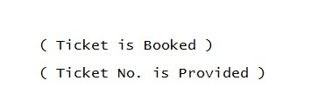

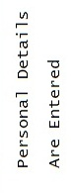 Details Are Stored in

Edit Details in Sign Up Form

Database (Flight Details & Passenger’s
Details)

Chooses Journey Type

Chooses One of The Available Flights

Coding of the Project

LOGIN FORM
Private Sub Command1_Click()
con.ConnectionString = "provider=microsoft.jet.oledb.4.0;data source=" & App.Path & "\airticket.mdb"
con.Open
rst.Open "select max(userial) from ulog", con, adOpenDynamic, adLockOptimistic, adCmdText
X = 1 + rst(0)
rst.Close
rst2.Open "select count(*) from aircust where uname=' " & Text1.Text & " ' and upass=' " & Text2.Text & " '", con, adOpenDynamic, adLockOptimistic, adCmdText
rst3.Open "select uname,upass from aircust where uname=' " & Text1.Text & " ' and upass=' " & Text2.Text & " '", con, adOpenDynamic, adLockOptimistic, adCmdText
rst4.Open "select count(*) from aircust where uname=' " & Text1.Text & " '", con, adOpenDynamic, adLockOptimistic, adCmdText
If Text1.Text = "" And Text2.Text = "" Then
MsgBox "Please Type Username & Password", vbExclamation, "Airline Reservation System"
Text1.SetFocus
rst2.Close
rst3.Close
rst4.Close
con.Close
ElseIf Text1.Text = "" Then
MsgBox "Please Type Username", vbExclamation, "Airline Reservation System"
Text1.SetFocus
rst2.Close
rst3.Close
rst4.Close
con.Close
ElseIf Text2.Text = "" Then
MsgBox "Please Type Password", vbExclamation, "Airline Reservation System"
rst2.Close
rst3.Close
rst4.Close
con.Close
Text2.SetFocus
ElseIf Text1.Text = "admin" And Text2.Text = "rohit" Then
con.Execute ("insert into ulog values(' " & X & " ',' " & Text1.Text & " ',' Rohit Sharma ',' " & Now & " ',' " & Format(Now, "dddd") & " ',' Administrator ')")
rst2.Close
rst3.Close
rst4.Close
con.Close
Form6.Show
Unload Me
ElseIf Val(rst4(0)) > 0 Then
If Val(rst2(0)) = 0 Then
MsgBox "Invalid Password", vbExclamation, "Airline Reservation System"
rst2.Close
rst3.Close
rst4.Close
con.Close
Text2.Text = Clear
Text2.SetFocus
Else: rst5.Open "select ufirst,ulast from aircust where uname = ' " & Text1.Text & " ' and upass = ' " & Text2.Text & " '", con, adOpenDynamic, adLockOptimistic, adCmdText
con.Execute ("insert into ulog values(' " & X & " ',' " & Text1.Text & " ','" & rst5(0) & LTrim(rst5(1)) & "',' " & Now & " ',' " & Format(Now, "dddd") & " ',' Local User ')")
rst2.Close
rst3.Close
rst4.Close
rst5.Close
con.Close
Form32.Show
Unload Me
End If
ElseIf Val(rst4(0)) = 0 Then
MsgBox "Invalid Username", vbExclamation, "Airline Reservation System"
rst2.Close
rst3.Close
rst4.Close
con.Close
Text1.Text = Clear
Text1.SetFocus
End If
End Sub

Private Sub Command1_GotFocus()
Command1.BackColor = &HFFFFC0
Command2.BackColor = &H8000000F
Command3.BackColor = &H8000000F
Command4.BackColor = &H8000000F
End Sub

Private Sub Command1_LostFocus()
Command1.BackColor = &H8000000F
End Sub

Private Sub Command1_MouseMove(Button As Integer, Shift As Integer, X As Single, Y As Single)
Command1.BackColor = &HFFFFC0
Command2.BackColor = &H8000000F
Command3.BackColor = &H8000000F
Command4.BackColor = &H8000000F
End Sub

Private Sub Command2_Click()
If MsgBox("Are You Sure You Want To Exit The Project ? ", vbQuestion + vbYesNo, "Airline Reservation System") = vbYes Then
End
End If
End Sub

Private Sub Command2_GotFocus()
Command2.BackColor = &HFFFFC0
Command1.BackColor = &H8000000F
Command3.BackColor = &H8000000F
Command4.BackColor = &H8000000F
End Sub

Private Sub Command2_MouseMove(Button As Integer, Shift As Integer, X As Single, Y As Single)
Command2.BackColor = &HFFFFC0
Command1.BackColor = &H8000000F
Command3.BackColor = &H8000000F
Command4.BackColor = &H8000000F

End Sub

Private Sub Command3_Click()
frmSplash1.Show
End Sub

Private Sub Command3_GotFocus()
Command3.BackColor = &HFFFFC0
Command2.BackColor = &H8000000F
Command1.BackColor = &H8000000F
Command4.BackColor = &H8000000F
End Sub

Private Sub Command3_MouseMove(Button As Integer, Shift As Integer, X As Single, Y As Single)
Command3.BackColor = &HFFFFC0
Command2.BackColor = &H8000000F
Command1.BackColor = &H8000000F
Command4.BackColor = &H8000000F

End Sub

Private Sub Command4_Click()
Form3.Show
Unload Me
End Sub

Private Sub Command4_GotFocus()
Command4.BackColor = &HFFFFC0
Command2.BackColor = &H8000000F
Command3.BackColor = &H8000000F
Command1.BackColor = &H8000000F
End Sub

Private Sub Command4_MouseMove(Button As Integer, Shift As Integer, X As Single, Y As Single)
Command4.BackColor = &HFFFFC0
Command2.BackColor = &H8000000F
Command3.BackColor = &H8000000F
Command1.BackColor = &H8000000F

End Sub

Private Sub Form_Activate()
Text1.SetFocus
End Sub

Private Sub Picture1_GotFocus()
Command2.BackColor = &H8000000F
End Sub

Private Sub Timer1_Timer()
Label3.Caption = Format(Now, "dddd")
Label4.Caption = Format(Now, "dd-mmm-yyyy")
Label5.Caption = Format(Now, "hh:mm:ss am/pm")
End Sub
Select Your Journey Type
Dim b As String
Private Sub Command4_Click()
b = Text2.Text
If Option7.Value = True Then
If (MsgBox("Are You Sure You Want To Save Your Details and Continue ?", vbYesNo + vbQuestion, "Airline Ticketing System") = vbYes) Then
If StrComp(Combo11.Text, Combo12.Text) = 0 Or Len(Combo11.Text) = 0 Or Len(Combo12.Text) = 0 Then
MsgBox "Both The Places Can't Be Same or Left Blanked", vbCritical, "Airline Ticketing System"
ElseIf StrComp(DTPicker3.Value, Format(Now, "dd-mm-yyyy")) < 0 Then
MsgBox "Historical Date in Departure Field is Not Allowed", vbCritical, "Airline Ticketing System"
ElseIf Len(Trim(Text2.Text)) = 0 Then
MsgBox "Please Type The Number", vbCritical, "Airline Ticketing System"
ElseIf StrComp(Label12.Caption, Text2.Text) <> 0 Then
MsgBox "Incorrect Number Typed", vbCritical, "Airline Ticketing System"
Text2.Text = Clear
Text2.SetFocus
Else: con.ConnectionString = "provider=microsoft.jet.oledb.4.0;data source=" & App.Path & "\airticket.mdb"
con.Open
con.Execute ("insert into intone values(' " & Text2.Text & " ',' ARSIOW' & '" & b & " ',' " & Option7.Caption & " ' , ' " & Combo11.Text & " ' , ' " & Combo12.Text & " ' , ' " & DTPicker3.Value & " ')")
MsgBox "Your Details Were Successfully Stored.", vbInformation, "Airline Ticketing System"
con.Close
Form9.Show
Unload Me
End If
Else: MsgBox "Your Details Were Not Submitted.", vbCritical, "Airline Ticketing System"
End If
ElseIf Option3.Value = True Then
If (MsgBox("Are You Sure You Want To Save Your Details and Continue ?", vbYesNo + vbQuestion, "Airline Ticketing System") = vbYes) Then
If StrComp(Combo11.Text, Combo12.Text) = 0 Or Len(Combo11.Text) = 0 Or Len(Combo12.Text) = 0 Then
MsgBox "Both The Places Can't Be Same or Left Blanked", vbCritical, "Airline Ticketing System"
ElseIf StrComp(DTPicker3.Value, Format(Now, "dd-mm-yyyy")) < 0 Then
MsgBox "Historical Date in Departure Field is Not Allowed", vbCritical, "Airline Ticketing System"
ElseIf StrComp(Format(DTPicker4.Value, "dd-mm-yyyy"), Format(DTPicker3.Value, "dd-mm-yyyy")) < 0 Or StrComp(Format(DTPicker4.Value, "yyyy"), Format(DTPicker3.Value, "yyyy")) < 0 Then
MsgBox "Return Date Can't Be Earlier Than Departure Date", vbCritical, "Airline Ticketing System"
ElseIf Len(Trim(Text2.Text)) = 0 Then
MsgBox "Please Type The Number", vbCritical, "Airline Ticketing System"
ElseIf StrComp(Label14.Caption, Text2.Text) <> 0 Then
MsgBox "Incorrect Number Typed", vbCritical, "Airline Ticketing System"
Text2.Text = Clear
Text2.SetFocus
Else: con.ConnectionString = "provider=microsoft.jet.oledb.4.0;data source=" & App.Path & "\airticket.mdb"
con.Open
con.Execute ("insert into intround values(' " & Text2.Text & " ',' ARSIRT' & '" & b & " ',' " & Option3.Caption & " ' , ' " & Combo11.Text & " ' , ' " & Combo12.Text & " ' , ' " & DTPicker3.Value & " ' , ' " & DTPicker4.Value & " ')")
MsgBox "Your Details Were Successfully Stored.", vbInformation, "Airline Ticketing System"
con.Close
Form92.Show
Unload Me
End If
Else: MsgBox "Your Details Were Not Submitted.", vbCritical, "Airline Ticketing System"
End If
End If
End Sub

Private Sub Command5_Click()
a = Text1.Text
If Option5.Value = True Then
If (MsgBox("Are You Sure You Want To Save Your Details and Continue ?", vbYesNo + vbQuestion, "Airline Ticketing System") = vbYes) Then
If StrComp(Combo1.Text, Combo2.Text) = 0 Or Len(Combo1.Text) = 0 Or Len(Combo2.Text) = 0 Then
MsgBox "Both The Places Can't Be Same or Left Blanked", vbCritical, "Airline Ticketing System"
ElseIf StrComp(DTPicker1.Value, Format(Now, "dd-mm-yyyy")) < 0 Then
MsgBox "Historical Date in Departure Field is Not Allowed", vbCritical, "Airline Ticketing System"
ElseIf Len(Trim(Text1.Text)) = 0 Then
MsgBox "Please Type The Number", vbCritical, "Airline Ticketing System"
ElseIf StrComp(Label9.Caption, Text1.Text) <> 0 Then
MsgBox "Incorrect Number Typed", vbCritical, "Airline Ticketing System"
Text1.Text = Clear
Text1.SetFocus
Else: con.ConnectionString = "provider=microsoft.jet.oledb.4.0;data source=" & App.Path & "\airticket.mdb"
con.Open
con.Execute ("insert into domone values(' " & Text1.Text & " ',' ARSDOW' & '" & a & " ',' " & Option5.Caption & " ' , ' " & Combo1.Text & " ' , ' " & Combo2.Text & " ' , ' " & DTPicker1.Value & " ') ")
MsgBox "Your Details Were Successfully Stored.", vbInformation, "Airline Ticketing System"
con.Close
Form8.Show
Unload Me
End If
Else: MsgBox "Your Details Were Not Submitted.", vbCritical, "Airline Ticketing System"
End If
ElseIf Option6.Value = True Then
If (MsgBox("Are You Sure You Want To Save Your Details and Continue ?", vbYesNo + vbQuestion, "Airline Ticketing System") = vbYes) Then
If StrComp(Combo1.Text, Combo2.Text) = 0 Or Len(Combo1.Text) = 0 Or Len(Combo2.Text) = 0 Then
MsgBox "Both The Places Can't Be Same or Left Blanked", vbCritical, "Airline Ticketing System"
ElseIf StrComp(DTPicker1.Value, Format(Now, "dd-mm-yyyy")) < 0 Then
MsgBox "Historical Date in Departure Field is Not Allowed", vbCritical, "Airline Ticketing System"
ElseIf StrComp(Format(DTPicker2.Value, "dd-mm-yyyy"), Format(DTPicker1.Value, "dd-mm-yyyy")) < 0 Or StrComp(Format(DTPicker2.Value, "yyyy"), Format(DTPicker1.Value, "yyyy")) < 0 Then
MsgBox "Return Date Can't Be Earlier Than Departure Date", vbCritical, "Airline Ticketing System"
ElseIf Len(Trim(Text1.Text)) = 0 Then
MsgBox "Please Type The Number", vbCritical, "Airline Ticketing System"
ElseIf StrComp(Label13.Caption, Text1.Text) <> 0 Then
MsgBox "Incorrect Number Typed", vbCritical, "Airline Ticketing System"
Text1.Text = Clear
Text1.SetFocus
Else: con.ConnectionString = "provider=microsoft.jet.oledb.4.0;data source=" & App.Path & "\airticket.mdb"
con.Open
con.Execute ("insert into domround values(' " & Text1.Text & " ',' ARSDRT' & '" & a & " ',' " & Option6.Caption & " ' , ' " & Combo1.Text & " ' , ' " & Combo2.Text & " ' , ' " & DTPicker1.Value & " ' , ' " & DTPicker2.Value & " ' )")
MsgBox "Your Details Were Successfully Stored.", vbInformation, "Airline Ticketing System"
con.Close
Form82.Show
Unload Me
End If
Else: MsgBox "Your Details Were Not Submitted.", vbCritical, "Airline Ticketing System"
End If
End If
End Sub
Private Sub Form_Load()
con.ConnectionString = "provider=microsoft.jet.oledb.4.0;data source=" & App.Path & "\airticket.mdb"
con.Open
rst1.Open "select * from dom order by domcity", con, adOpenDynamic, adLockOptimistic, adCmdText
rst1.MoveFirst
While rst1.EOF <> True
Combo1.AddItem rst1(0)
Combo2.AddItem rst1(0)
rst1.MoveNext
Wend
rst1.Close
rst2.Open "select * from intt order by intcity", con, adOpenDynamic, adLockOptimistic, adCmdText
rst2.MoveFirst
While rst2.EOF <> True
Combo12.AddItem rst2(0)
rst2.MoveNext
Wend
rst2.Close
rst2.Open "select * from dom order by domcity", con, adOpenDynamic, adLockOptimistic, adCmdText
rst2.MoveFirst
While rst2.EOF <> True
Combo11.AddItem rst2(0)
rst2.MoveNext
Wend
rst2.Close
rst3.Open "select max(fno) from domone", con, adOpenDynamic, adLockOptimistic, adCmdText
Label9.Caption = 1 + rst3(0)
rst3.Close
rst3.Open "select max(fno) from domround", con, adOpenDynamic, adLockOptimistic, adCmdText
Label13.Caption = 1 + rst3(0)
rst3.Close
rst3.Open "select max(fno) from intone", con, adOpenDynamic, adLockOptimistic, adCmdText
Label12.Caption = 1 + rst3(0)
rst3.Close
rst3.Open "select max(fno) from intround", con, adOpenDynamic, adLockOptimistic, adCmdText
Label14.Caption = 1 + rst3(0)
rst3.Close
con.Close
End Sub
Private Sub mnuLogOut_Click()
MsgBox "Successfully Logged Out", vbInformation, "Airline Ticketing System"
Form1.Show
Unload Me
End Sub

SIGN UP FORM
Private Sub Command1_Click()
con.ConnectionString = "Provider=Microsoft.Jet.OLEDB.4.0;Data Source=" & App.Path & "\airticket.mdb;"
con.Open
If Len(Trim(Combo1.Text)) > 0 And Len(Trim(Combo2.Text)) > 0 And Len(Trim(Combo3.Text)) > 0 And Len(Trim(MaskEdBox2.Text)) > 0 And Len(Trim(MaskEdBox3.Text)) > 0 And Len(Trim(Text3.Text)) > 0 And Len(Trim(Text4.Text)) > 0 And Len(Trim(MaskEdBox1.Text)) > 0 And Len(Trim(Text6.Text)) > 0 And Len(Trim(Text1.Text)) > 0 Then
rst1.Open "select count(*) from aircust where uname=' " & Text3.Text & " '", con, adOpenDynamic, adLockOptimistic, adCmdText
If rst1(0) > 0 Then
MsgBox "Username is Not Available", vbCritical, "Airline Ticketing System"
Text3.SetFocus
rst1.Close
con.Close
ElseIf Len(Trim(Text3.Text)) < 6 Then
MsgBox "Username Must Be Atleast of 6 Characters", vbCritical, "Airline Ticketing System"
Text3.SetFocus
rst1.Close
con.Close
ElseIf StrComp(Right(Trim(Combo3.Text), 4), ".com") <> 0 And StrComp(Right(Trim(Combo3.Text), 6), ".co.in") <> 0 Then
MsgBox "E-mail ID should end with .com or .co.in", vbCritical, "Airline Ticketing System"
Combo3.SetFocus
rst1.Close
con.Close
ElseIf Len(Trim(MaskEdBox1.Text)) <> 10 Then
MsgBox "Contact Number Must Be of 10 Digits", vbCritical, "Airline Ticketing System"
MaskEdBox1.SetFocus
rst1.Close
con.Close
ElseIf StrComp(DTPicker1.Value, Format(Now, "dd-mm-yyyy")) > 0 Then
MsgBox "Invalid Date of Birth", vbCritical, "Airline Ticketing System"
DTPicker1.SetFocus
rst1.Close
con.Close
Else: con.Execute ("insert into aircust values(' " & Trim(MaskEdBox2.Text) & " ',' " & Trim(MaskEdBox3.Text) & " ',' " & Trim(Text3.Text) & " ',' " & Text4.Text & " ',' " & Combo1.Text & " ',' " & DTPicker1.Value & " ',' " & Trim(Text1.Text) & Trim(Label14.Caption) & Trim(Combo3.Text) & " ',' " & Label8.Caption & Trim(MaskEdBox1.Text) & " ',' " & Combo2.Text & " ',' " & Trim(Text6.Text) & " ')")
con.Close
MsgBox "Sign Up Complete.", vbInformation, "Airline Ticketing System"
MsgBox "Username : " & Text3.Text & " Password : " & Text4.Text, vbInformation, "Airline Ticketing System"
DTPicker1.Enabled = False
Private Sub Command3_Click()
MaskEdBox2.Text = LCase(Left(MaskEdBox2.Text, 1)) & Mid(MaskEdBox2.Text, 2)
End Sub
Private Sub Command4_Click()
MaskEdBox3.Text = LCase(Left(MaskEdBox3.Text, 1)) & Mid(MaskEdBox3.Text, 2)
End Sub
Private Sub Form_Activate()
DTPicker1.Value = Format(Now, "dd-mm-yyyy")
End Sub
Private Sub Form_Load()
Combo1.AddItem "Male"
Combo1.AddItem "Female"
con.ConnectionString = "Provider=Microsoft.Jet.OLEDB.4.0;Data Source=" & App.Path & "\airticket.mdb;"
con.Open
rst.Open "select sec from q", con, adOpenDynamic, adLockOptimistic, adCmdText
rst.MoveFirst
While rst.EOF <> True
Combo2.AddItem rst(0)
rst.MoveNext
Wend
rst.Close
con.Close
Combo3.AddItem "gmail.com"
Combo3.AddItem "yahoo.com"
Combo3.AddItem "hotmail.com"
Combo3.AddItem "yandex.com"
Combo3.AddItem "Let Me Choose..."
End Sub
Private Sub Label17_Click()
frmSplash3.Show
End Sub
Private Sub MaskEdBox1_Change()
If Len(Trim(MaskEdBox1.Text)) < 10 Then
MaskEdBox1.ForeColor = &HFF&
ElseIf Len(Trim(MaskEdBox1.Text)) = 10 Then
MaskEdBox1.ForeColor = &H8000&
End If
End Sub
Private Sub MaskEdBox2_LostFocus()
MaskEdBox2.Text = UCase(Left(MaskEdBox2.Text, 1)) & Mid(MaskEdBox2.Text, 2)
Command3.Visible = True
End Sub
Private Sub MaskEdBox3_LostFocus()
MaskEdBox3.Text = UCase(Left(MaskEdBox3.Text, 1)) & Mid(MaskEdBox3.Text, 2)
Command4.Visible = True
End Sub
Private Sub Text3_Change()
con.ConnectionString = "Provider=Microsoft.Jet.OLEDB.4.0;Data Source=" & App.Path & "\airticket.mdb;"
con.Open
rst.Open "select count(*) from aircust where uname = ' " & Text3.Text & " '", con, adOpenDynamic, adLockOptimistic, adCmdText
If rst(0) > 0 Then
Label12.Caption = "Username Not Available"
Label12.ForeColor = &HFF&
Text3.ForeColor = &HFF&
Else: Label12.Caption = "Username Available"
If Len(Trim(Text3.Text)) < 6 Then
Label12.Caption = "Username Must Be Atleast of 6 Characters"
Label12.ForeColor = &HFF&
Text3.ForeColor = &HFF&
Else: Label12.ForeColor = &H8000&
Text3.ForeColor = &H8000&
End If
End If
rst.Close
con.Close
End Sub
Private Sub Text3_GotFocus()
If Len(Trim(Text3.Text)) = 0 Then
Label12.Caption = "*Make Sure That Your Username is Unique"
End If
End Sub
Private Sub Text3_LostFocus()
If Len(Trim(Text3.Text)) = 0 Then
Label12.Caption = Clear
End If
End Sub
Private Sub Text4_Change()
If Len(Trim(Text4.Text)) > 10 Then
Label11.Caption = "Strong Password"
Label11.ForeColor = &H8000&
Text4.ForeColor = &H8000&
ElseIf Len(Trim(Text4.Text)) > 7 Then
Label11.Caption = "Fair Password"
Label11.ForeColor = &HFF0000
Text4.ForeColor = &HFF0000
Else: Label11.Caption = "Weak Password"
Label11.ForeColor = &HFF&
Text4.ForeColor = &HFF&
End If
End Sub
Private Sub Text4_GotFocus()
If Len(Trim(Text4.Text)) = 0 Then
Label11.Caption = "Password Should Contain More Than 7 Characters"
End If
End Sub
Private Sub Text4_LostFocus()
If Len(Trim(Text4.Text)) = 0 Then
Label11.Caption = Clear
End If
End Sub

Book Your Flight Here

Dim n As String
Private Sub Command10_Click()
MsgBox "Your Flight is Successfully Booked.", vbInformation, "Airline Ticketing System"
Form2.Show
Unload Me
End Sub
Private Sub Command6_Click()
If Option1.Value = True Then
If (MsgBox("Are You Sure You Want To Confirm Your Flight ?", vbYesNo + vbQuestion, "Airline Ticketing System") = vbYes) Then
con.ConnectionString = "provider=microsoft.jet.oledb.4.0;data source=" & App.Path & "\airticket.mdb"
con.Open
rst.Open "select max(fno) from confirmintround", con, adOpenDynamic, adLockOptimistic, adCmdText
n = 1 + Val(rst(0))
rst.Close
con.Execute ("insert into confirmintround values(' " & n & " ',' ARSIRT' & '" & n & " ',' Emirates 1 ',' " & Option1.Caption & " ')")
MsgBox "Your Flight Has Been Confirmed", vbInformation, "Airline Ticketing System"
rst5.Open "select regno from confirmintround where regno = ' ARSIRT' & '" & n & " '", con, adOpenDynamic, adLockOptimistic, adCmdText
MsgBox "Your Registration Number is : " & rst5(0), vbInformation, "Airline Ticketing System"
rst5.Close
con.Close
End If
ElseIf Option2.Value = True Then
If (MsgBox("Are You Sure You Want To Confirm Your Flight ?", vbYesNo + vbQuestion, "Airline Ticketing System") = vbYes) Then
con.ConnectionString = "provider=microsoft.jet.oledb.4.0;data source=" & App.Path & "\airticket.mdb"
con.Open
rst.Open "select max(fno) from confirmintround", con, adOpenDynamic, adLockOptimistic, adCmdText
n = 1 + Val(rst(0))
rst.Close
con.Execute ("insert into confirmintround values(' " & n & " ',' ARSIRT' & '" & n & " ',' Emirates 2 ',' " & Option2.Caption & " ')")
MsgBox "Your Flight Has Been Confirmed", vbInformation, "Airline Ticketing System"
rst5.Open "select regno from confirmintround where regno = ' ARSIRT' & '" & n & " '", con, adOpenDynamic, adLockOptimistic, adCmdText
MsgBox "Your Registration Number is : " & rst5(0), vbInformation, "Airline Ticketing System"
rst5.Close
con.Close
End If
ElseIf Option3.Value = True Then
If (MsgBox("Are You Sure You Want To Confirm Your Flight ?", vbYesNo + vbQuestion, "Airline Ticketing System") = vbYes) Then
con.ConnectionString = "provider=microsoft.jet.oledb.4.0;data source=" & App.Path & "\airticket.mdb"
con.Open
rst.Open "select max(fno) from confirmintround", con, adOpenDynamic, adLockOptimistic, adCmdText
n = 1 + Val(rst(0))
rst.Close
con.Execute ("insert into confirmintround values(' " & n & " ',' ARSIRT' & '" & n & " ',' Emirates 3 ',' " & Option3.Caption & " ')")
MsgBox "Your Flight Has Been Confirmed", vbInformation, "Airline Ticketing System"
rst5.Open "select regno from confirmintround where regno = ' ARSIRT' & '" & n & " '", con, adOpenDynamic, adLockOptimistic, adCmdText
MsgBox "Your Registration Number is : " & rst5(0), vbInformation, "Airline Ticketing System"
rst5.Close
con.Close
End If
Else: MsgBox "You Have Not Selected Any Flight.", vbCritical, "Airline Ticketing System"
End If
End Sub
Private Sub Command7_Click()
If Option4.Value = True Then
If (MsgBox("Are You Sure You Want To Confirm Your Flight ?", vbYesNo + vbQuestion, "Airline Ticketing System") = vbYes) Then
con.ConnectionString = "provider=microsoft.jet.oledb.4.0;data source=" & App.Path & "\airticket.mdb"
con.Open
rst.Open "select max(fno) from confirmintround", con, adOpenDynamic, adLockOptimistic, adCmdText
n = 1 + Val(rst(0))
rst.Close
con.Execute ("insert into confirmintround values(' " & n & " ',' ARSIRT' & '" & n & " ',' British Airways 1 ',' " & Option4.Caption & " ')")
MsgBox "Your Flight Has Been Confirmed", vbInformation, "Airline Ticketing System"
rst5.Open "select regno from confirmintround where regno = ' ARSIRT' & '" & n & " '", con, adOpenDynamic, adLockOptimistic, adCmdText
MsgBox "Your Registration Number is : " & rst5(0), vbInformation, "Airline Ticketing System"
rst5.Close
con.Close
End If
ElseIf Option5.Value = True Then
If (MsgBox("Are You Sure You Want To Confirm Your Flight ?", vbYesNo + vbQuestion, "Airline Ticketing System") = vbYes) Then
con.ConnectionString = "provider=microsoft.jet.oledb.4.0;data source=" & App.Path & "\airticket.mdb"
con.Open
rst.Open "select max(fno) from confirmintround", con, adOpenDynamic, adLockOptimistic, adCmdText
n = 1 + Val(rst(0))
rst.Close
con.Execute ("insert into confirmintround values(' " & n & " ',' ARSIRT' & '" & n & " ',' British Airways 2 ',' " & Option5.Caption & " ')")
MsgBox "Your Flight Has Been Confirmed", vbInformation, "Airline Ticketing System"
rst5.Open "select regno from confirmintround where regno = ' ARSIRT' & '" & n & " '", con, adOpenDynamic, adLockOptimistic, adCmdText
MsgBox "Your Registration Number is : " & rst5(0), vbInformation, "Airline Ticketing System"
rst5.Close
con.Close
End If
ElseIf Option6.Value = True Then
If (MsgBox("Are You Sure You Want To Confirm Your Flight ?", vbYesNo + vbQuestion, "Airline Ticketing System") = vbYes) Then
con.ConnectionString = "provider=microsoft.jet.oledb.4.0;data source=" & App.Path & "\airticket.mdb"
con.Open
rst.Open "select max(fno) from confirmintround", con, adOpenDynamic, adLockOptimistic, adCmdText
n = 1 + Val(rst(0))
rst.Close
con.Execute ("insert into confirmintround values(' " & n & " ',' ARSIRT' & '" & n & " ',' British Airways 3 ',' " & Option6.Caption & " ')")
MsgBox "Your Flight Has Been Confirmed", vbInformation, "Airline Ticketing System"
rst5.Open "select regno from confirmintround where regno = ' ARSIRT' & '" & n & " '", con, adOpenDynamic, adLockOptimistic, adCmdText
MsgBox "Your Registration Number is : " & rst5(0), vbInformation, "Airline Ticketing System"
rst5.Close
con.Close
End If
Else: MsgBox "You Have Not Selected Any Flight.", vbCritical, "Airline Ticketing System"
End If
End Sub
Private Sub Command8_Click()
If Option7.Value = True Then
If (MsgBox("Are You Sure You Want To Confirm Your Flight ?", vbYesNo + vbQuestion, "Airline Ticketing System") = vbYes) Then
con.ConnectionString = "provider=microsoft.jet.oledb.4.0;data source=" & App.Path & "\airticket.mdb"
con.Open
rst.Open "select max(fno) from confirmintround", con, adOpenDynamic, adLockOptimistic, adCmdText
n = 1 + Val(rst(0))
rst.Close
con.Execute ("insert into confirmintround values(' " & n & " ',' ARSIRT' & '" & n & " ',' Delta Airlines 1 ',' " & Option7.Caption & " ')")
MsgBox "Your Flight Has Been Confirmed", vbInformation, "Airline Ticketing System"
rst5.Open "select regno from confirmintround where regno = ' ARSIRT' & '" & n & " '", con, adOpenDynamic, adLockOptimistic, adCmdText
MsgBox "Your Registration Number is : " & rst5(0), vbInformation, "Airline Ticketing System"
rst5.Close
con.Close
End If
ElseIf Option8.Value = True Then
If (MsgBox("Are You Sure You Want To Confirm Your Flight ?", vbYesNo + vbQuestion, "Airline Ticketing System") = vbYes) Then
con.ConnectionString = "provider=microsoft.jet.oledb.4.0;data source=" & App.Path & "\airticket.mdb"
con.Open
rst.Open "select max(fno) from confirmintround", con, adOpenDynamic, adLockOptimistic, adCmdText
n = 1 + Val(rst(0))
rst.Close
con.Execute ("insert into confirmintround values(' " & n & " ',' ARSIRT' & '" & n & " ',' Delta Airlines 2 ',' " & Option8.Caption & " ')")
MsgBox "Your Flight Has Been Confirmed", vbInformation, "Airline Ticketing System"
rst5.Open "select regno from confirmintround where regno = ' ARSIRT' & '" & n & " '", con, adOpenDynamic, adLockOptimistic, adCmdText
MsgBox "Your Registration Number is : " & rst5(0), vbInformation, "Airline Ticketing System"
rst5.Close
con.Close
End If
ElseIf Option9.Value = True Then
If (MsgBox("Are You Sure You Want To Confirm Your Flight ?", vbYesNo + vbQuestion, "Airline Ticketing System") = vbYes) Then
con.ConnectionString = "provider=microsoft.jet.oledb.4.0;data source=" & App.Path & "\airticket.mdb"
con.Open
rst.Open "select max(fno) from confirmintround", con, adOpenDynamic, adLockOptimistic, adCmdText
n = 1 + Val(rst(0))
rst.Close
con.Execute ("insert into confirmintround values(' " & n & " ',' ARSIRT' & '" & n & " ',' Delta Airlines 3 ',' " & Option9.Caption & " ')")
MsgBox "Your Flight Has Been Confirmed", vbInformation, "Airline Ticketing System"
rst5.Open "select regno from confirmintround where regno = ' ARSIRT' & '" & n & " '", con, adOpenDynamic, adLockOptimistic, adCmdText
MsgBox "Your Registration Number is : " & rst5(0), vbInformation, "Airline Ticketing System"
rst5.Close
con.Close
Else: MsgBox "You Have Not Selected Any Flight.", vbCritical, "Airline Ticketing System"
End If
End Sub
Private Sub Command9_Click()
If Option10.Value = True Then
If (MsgBox("Are You Sure You Want To Confirm Your Flight ?", vbYesNo + vbQuestion, "Airline Ticketing System") = vbYes) Then
con.ConnectionString = "provider=microsoft.jet.oledb.4.0;data source=" & App.Path & "\airticket.mdb"
con.Open
rst.Open "select max(fno) from confirmintround", con, adOpenDynamic, adLockOptimistic, adCmdText
n = 1 + Val(rst(0))
rst.Close
con.Execute ("insert into confirmintround values(' " & n & " ',' ARSIRT' & '" & n & " ',' Etihad Airways 1 ',' " & Option10.Caption & " ')")
MsgBox "Your Flight Has Been Confirmed", vbInformation, "Airline Ticketing System"
rst5.Open "select regno from confirmintround where regno = ' ARSIRT' & '" & n & " '", con, adOpenDynamic, adLockOptimistic, adCmdText
MsgBox "Your Registration Number is : " & rst5(0), vbInformation, "Airline Ticketing System"
rst5.Close
con.Close
ElseIf Option11.Value = True Then
If (MsgBox("Are You Sure You Want To Confirm Your Flight ?", vbYesNo + vbQuestion, "Airline Ticketing System") = vbYes) Then
con.ConnectionString = "provider=microsoft.jet.oledb.4.0;data source=" & App.Path & "\airticket.mdb"
con.Open
rst.Open "select max(fno) from confirmintround", con, adOpenDynamic, adLockOptimistic, adCmdText
n = 1 + Val(rst(0))
rst.Close
con.Execute ("insert into confirmintround values(' " & n & " ',' ARSIRT' & '" & n & " ',' Etihad Airways 2 ',' " & Option11.Caption & " ')")
MsgBox "Your Flight Has Been Confirmed", vbInformation, "Airline Ticketing System"
rst5.Open "select regno from confirmintround where regno = ' ARSIRT' & '" & n & " '", con, adOpenDynamic, adLockOptimistic, adCmdText
MsgBox "Your Registration Number is : " & rst5(0), vbInformation, "Airline Ticketing System"
rst5.Close
con.Close
End If
ElseIf Option12.Value = True Then
If (MsgBox("Are You Sure You Want To Confirm Your Flight ?", vbYesNo + vbQuestion, "Airline Ticketing System") = vbYes) Then
con.ConnectionString = "provider=microsoft.jet.oledb.4.0;data source=" & App.Path & "\airticket.mdb"
con.Open
rst.Open "select max(fno) from confirmintround", con, adOpenDynamic, adLockOptimistic, adCmdText
n = 1 + Val(rst(0))
rst.Close
con.Execute ("insert into confirmintround values(' " & n & " ',' ARSIRT' & '" & n & " ',' Etihad Airways 3 ',' " & Option12.Caption & " ')")
MsgBox "Your Flight Has Been Confirmed", vbInformation, "Airline Ticketing System"
rst5.Open "select regno from confirmintround where regno = ' ARSIRT' & '" & n & " '", con, adOpenDynamic, adLockOptimistic, adCmdText
MsgBox "Your Registration Number is : " & rst5(0), vbInformation, "Airline Ticketing System"
rst5.Close
con.Close
Else: MsgBox "You Have Not Selected Any Flight.", vbCritical, "Airline Ticketing System"
End If
End Sub

Booking A Flight

Dim n As String, flag As Integer
Private Sub Command1_Click()
If MsgBox("Are You Sure You Want To Log Out ? ", vbQuestion + vbYesNo, "Airline Reservation System") = vbYes Then
MsgBox "Please Login To Continue", vbInformation, "Airline Reservation System"

If flag = 0 Then
con.ConnectionString = "provider=microsoft.jet.oledb.4.0;data source=" & App.Path & "\airticket.mdb"
con.Open
rst.Open "select max(fno) from domone", con, adOpenDynamic, adLockOptimistic, adCmdText
con.Execute ("delete from domone where fno = " & rst(0))
rst.Close
con.Close
End If

Form1.Show
Unload Me
End If
End Sub

Private Sub Command11_Click()
Form32.Show
Unload Me
End Sub

Private Sub Command2_Click()
Frame2.Visible = True
Command6.Visible = True
End Sub

Private Sub Command3_Click()
Frame3.Visible = True
Command7.Visible = True
End Sub

Private Sub Command4_Click()
Frame4.Visible = True
Command8.Visible = True
End Sub

Private Sub Command5_Click()
Frame5.Visible = True
Command9.Visible = True
End Sub

Private Sub Command6_Click()
If Option1.Value = True Then
If (MsgBox("Are You Sure You Want To Confirm Your Flight ?", vbYesNo + vbQuestion, "Airline Reservation System") = vbYes) Then
con.ConnectionString = "provider=microsoft.jet.oledb.4.0;data source=" & App.Path & "\airticket.mdb"
con.Open
rst.Open "select max(fno) from confirmdomone", con, adOpenDynamic, adLockOptimistic, adCmdText
n = 1 + Val(rst(0))
rst.Close
con.Execute ("insert into confirmdomone values(' " & n & " ',' ARSDOW' & '" & n & " ',' Spicejet 1 ',' " & Option1.Caption & " ')")
MsgBox "Your Flight Has Been Confirmed", vbInformation, "Airline Reservation System"
rst5.Open "select regno from confirmdomone where regno = ' ARSDOW' & '" & n & " '", con, adOpenDynamic, adLockOptimistic, adCmdText
MsgBox "Your Registration Number is : " & rst5(0), vbInformation, "Airline Reservation System"
rst5.Close
con.Close
Command6.Enabled = False
Frame2.Enabled = False
Frame3.Enabled = False
Frame4.Enabled = False
Frame5.Enabled = False
Command2.Enabled = False
Command3.Enabled = False
Command4.Enabled = False
Command5.Enabled = False
Command7.Enabled = False
Command8.Enabled = False
Command9.Enabled = False
Command11.Enabled = True
flag = 1
Form4.Show
Unload Me
End If
ElseIf Option2.Value = True Then
If (MsgBox("Are You Sure You Want To Confirm Your Flight ?", vbYesNo + vbQuestion, "Airline Reservation System") = vbYes) Then
con.ConnectionString = "provider=microsoft.jet.oledb.4.0;data source=" & App.Path & "\airticket.mdb"
con.Open
rst.Open "select max(fno) from confirmdomone", con, adOpenDynamic, adLockOptimistic, adCmdText
n = 1 + Val(rst(0))
rst.Close
con.Execute ("insert into confirmdomone values(' " & n & " ',' ARSDOW' & '" & n & " ',' Spicejet 2 ',' " & Option2.Caption & " ')")
MsgBox "Your Flight Has Been Confirmed", vbInformation, "Airline Reservation System"
rst5.Open "select regno from confirmdomone where regno = ' ARSDOW' & '" & n & " '", con, adOpenDynamic, adLockOptimistic, adCmdText
MsgBox "Your Registration Number is : " & rst5(0), vbInformation, "Airline Reservation System"
rst5.Close
con.Close
Command6.Enabled = False
Frame2.Enabled = False
Frame3.Enabled = False
Frame4.Enabled = False
Frame5.Enabled = False
Command2.Enabled = False
Command3.Enabled = False
Command4.Enabled = False
Command5.Enabled = False
Command7.Enabled = False
Command8.Enabled = False
Command9.Enabled = False
Command11.Enabled = True
flag = 1
Form4.Show
Unload Me
End If
ElseIf Option3.Value = True Then
If (MsgBox("Are You Sure You Want To Confirm Your Flight ?", vbYesNo + vbQuestion, "Airline Reservation System") = vbYes) Then
con.ConnectionString = "provider=microsoft.jet.oledb.4.0;data source=" & App.Path & "\airticket.mdb"
con.Open
rst.Open "select max(fno) from confirmdomone", con, adOpenDynamic, adLockOptimistic, adCmdText
n = 1 + Val(rst(0))
rst.Close
con.Execute ("insert into confirmdomone values(' " & n & " ',' ARSDOW' & '" & n & " ',' Spicejet 3 ',' " & Option3.Caption & " ')")
MsgBox "Your Flight Has Been Confirmed.", vbInformation, "Airline Reservation System"
rst5.Open "select regno from confirmdomone where regno = ' ARSDOW' & '" & n & " '", con, adOpenDynamic, adLockOptimistic, adCmdText
MsgBox "Your Registration Number is : " & rst5(0), vbInformation, "Airline Reservation System"
rst5.Close
con.Close
Command6.Enabled = False
Frame2.Enabled = False
Frame3.Enabled = False
Frame4.Enabled = False
Frame5.Enabled = False
Command2.Enabled = False
Command3.Enabled = False
Command4.Enabled = False
Command5.Enabled = False
Command7.Enabled = False
Command8.Enabled = False
Command9.Enabled = False
Command11.Enabled = True
flag = 1
Form4.Show
Unload Me
End If
Else: MsgBox "You Have Not Selected Any Flight.", vbCritical, "Airline Reservation System"
End If
End Sub

Private Sub Command7_Click()
If Option4.Value = True Then
If (MsgBox("Are You Sure You Want To Confirm Your Flight ?", vbYesNo + vbQuestion, "Airline Reservation System") = vbYes) Then
con.ConnectionString = "provider=microsoft.jet.oledb.4.0;data source=" & App.Path & "\airticket.mdb"
con.Open
rst.Open "select max(fno) from confirmdomone", con, adOpenDynamic, adLockOptimistic, adCmdText
n = 1 + Val(rst(0))
rst.Close
con.Execute ("insert into confirmdomone values(' " & n & " ',' ARSDOW' & '" & n & " ',' Indigo 1 ',' " & Option4.Caption & " ')")
MsgBox "Your Flight Has Been Confirmed.", vbInformation, "Airline Reservation System"
rst5.Open "select regno from confirmdomone where regno = ' ARSDOW' & '" & n & " '", con, adOpenDynamic, adLockOptimistic, adCmdText
MsgBox "Your Registration Number is : " & rst5(0), vbInformation, "Airline Reservation System"
rst5.Close
con.Close
Command6.Enabled = False
Option1.Enabled = False
Option2.Enabled = False
Option3.Enabled = False
Frame3.Enabled = False
Frame4.Enabled = False
Frame5.Enabled = False
Command2.Enabled = False
Command3.Enabled = False
Command4.Enabled = False
Command5.Enabled = False
Command7.Enabled = False
Command8.Enabled = False
Command9.Enabled = False
Command11.Enabled = True
flag = 1
Form4.Show
Unload Me
End If
ElseIf Option5.Value = True Then
If (MsgBox("Are You Sure You Want To Confirm Your Flight ?", vbYesNo + vbQuestion, "Airline Reservation System") = vbYes) Then
con.ConnectionString = "provider=microsoft.jet.oledb.4.0;data source=" & App.Path & "\airticket.mdb"
con.Open
rst.Open "select max(fno) from confirmdomone", con, adOpenDynamic, adLockOptimistic, adCmdText
n = 1 + Val(rst(0))
rst.Close
con.Execute ("insert into confirmdomone values(' " & n & " ',' ARSDOW' & '" & n & " ',' Indigo 2 ',' " & Option5.Caption & " ')")
MsgBox "Your Flight Has Been Confirmed.", vbInformation, "Airline Reservation System"
rst5.Open "select regno from confirmdomone where regno = ' ARSDOW' & '" & n & " '", con, adOpenDynamic, adLockOptimistic, adCmdText
MsgBox "Your Registration Number is : " & rst5(0), vbInformation, "Airline Reservation System"
rst5.Close
con.Close
Command6.Enabled = False
Option1.Enabled = False
Option2.Enabled = False
Option3.Enabled = False
Frame3.Enabled = False
Frame4.Enabled = False
Frame5.Enabled = False
Command2.Enabled = False
Command3.Enabled = False
Command4.Enabled = False
Command5.Enabled = False
Command7.Enabled = False
Command8.Enabled = False
Command9.Enabled = False
Command11.Enabled = True
flag = 1
Form4.Show
Unload Me
End If
ElseIf Option6.Value = True Then
If (MsgBox("Are You Sure You Want To Confirm Your Flight ?", vbYesNo + vbQuestion, "Airline Reservation System") = vbYes) Then
con.ConnectionString = "provider=microsoft.jet.oledb.4.0;data source=" & App.Path & "\airticket.mdb"
con.Open
rst.Open "select max(fno) from confirmdomone", con, adOpenDynamic, adLockOptimistic, adCmdText
n = 1 + Val(rst(0))
rst.Close
con.Execute ("insert into confirmdomone values(' " & n & " ',' ARSDOW' & '" & n & " ',' Indigo 3 ',' " & Option6.Caption & " ')")
MsgBox "Your Flight Has Been Confirmed.", vbInformation, "Airline Reservation System"
rst5.Open "select regno from confirmdomone where regno = ' ARSDOW' & '" & n & " '", con, adOpenDynamic, adLockOptimistic, adCmdText
MsgBox "Your Registration Number is : " & rst5(0), vbInformation, "Airline Reservation System"
rst5.Close
con.Close
Command6.Enabled = False
Option1.Enabled = False
Option2.Enabled = False
Option3.Enabled = False
Frame3.Enabled = False
Frame4.Enabled = False
Frame5.Enabled = False
Command2.Enabled = False
Command3.Enabled = False
Command4.Enabled = False
Command5.Enabled = False
Command7.Enabled = False
Command8.Enabled = False
Command9.Enabled = False
Command11.Enabled = True
flag = 1
Form4.Show
Unload Me
End If
Else: MsgBox "You Have Not Selected Any Flight.", vbCritical, "Airline Reservation System"
End If
End Sub

Private Sub Command8_Click()
If Option7.Value = True Then
If (MsgBox("Are You Sure You Want To Confirm Your Flight ?", vbYesNo + vbQuestion, "Airline Reservation System") = vbYes) Then
con.ConnectionString = "provider=microsoft.jet.oledb.4.0;data source=" & App.Path & "\airticket.mdb"
con.Open
rst.Open "select max(fno) from confirmdomone", con, adOpenDynamic, adLockOptimistic, adCmdText
n = 1 + Val(rst(0))
rst.Close
con.Execute ("insert into confirmdomone values(' " & n & " ',' ARSDOW' & '" & n & " ',' Air India 1 ',' " & Option7.Caption & " ')")
MsgBox "Your Flight Has Been Confirmed.", vbInformation, "Airline Reservation System"
rst5.Open "select regno from confirmdomone where regno = ' ARSDOW' & '" & n & " '", con, adOpenDynamic, adLockOptimistic, adCmdText
MsgBox "Your Registration Number is : " & rst5(0), vbInformation, "Airline Reservation System"
rst5.Close
con.Close
Command6.Enabled = False
Option1.Enabled = False
Option2.Enabled = False
Option3.Enabled = False
Frame3.Enabled = False
Frame4.Enabled = False
Frame5.Enabled = False
Command2.Enabled = False
Command3.Enabled = False
Command4.Enabled = False
Command5.Enabled = False
Command7.Enabled = False
Command8.Enabled = False
Command9.Enabled = False
Command11.Enabled = True
flag = 1
Form4.Show
Unload Me
End If
ElseIf Option8.Value = True Then
If (MsgBox("Are You Sure You Want To Confirm Your Flight ?", vbYesNo + vbQuestion, "Airline Reservation System") = vbYes) Then
con.ConnectionString = "provider=microsoft.jet.oledb.4.0;data source=" & App.Path & "\airticket.mdb"
con.Open
rst.Open "select max(fno) from confirmdomone", con, adOpenDynamic, adLockOptimistic, adCmdText
n = 1 + Val(rst(0))
rst.Close
con.Execute ("insert into confirmdomone values(' " & n & " ',' ARSDOW' & '" & n & " ',' Air India 2 ',' " & Option8.Caption & " ')")
MsgBox "Your Flight Has Been Confirmed.", vbInformation, "Airline Reservation System"
rst5.Open "select regno from confirmdomone where regno = ' ARSDOW' & '" & n & " '", con, adOpenDynamic, adLockOptimistic, adCmdText
MsgBox "Your Registration Number is : " & rst5(0), vbInformation, "Airline Reservation System"
rst5.Close
con.Close
Command6.Enabled = False
Option1.Enabled = False
Option2.Enabled = False
Option3.Enabled = False
Frame3.Enabled = False
Frame4.Enabled = False
Frame5.Enabled = False
Command2.Enabled = False
Command3.Enabled = False
Command4.Enabled = False
Command5.Enabled = False
Command7.Enabled = False
Command8.Enabled = False
Command9.Enabled = False
Command11.Enabled = True
flag = 1
Form4.Show
Unload Me
End If
ElseIf Option9.Value = True Then
If (MsgBox("Are You Sure You Want To Confirm Your Flight ?", vbYesNo + vbQuestion, "Airline Reservation System") = vbYes) Then
con.ConnectionString = "provider=microsoft.jet.oledb.4.0;data source= " & App.Path & "\airticket.mdb"
con.Open
rst.Open "select max(fno) from confirmdomone", con, adOpenDynamic, adLockOptimistic, adCmdText
n = 1 + Val(rst(0))
rst.Close
con.Execute ("insert into confirmdomone values(' " & n & " ',' ARSDOW' & '" & n & " ',' Air India 3 ',' " & Option9.Caption & " ')")
MsgBox "Your Flight Has Been Confirmed.", vbInformation, "Airline Reservation System"
rst5.Open "select regno from confirmdomone where regno = ' ARSDOW' & '" & n & " '", con, adOpenDynamic, adLockOptimistic, adCmdText
MsgBox "Your Registration Number is : " & rst5(0), vbInformation, "Airline Reservation System"
rst5.Close
con.Close
Command6.Enabled = False
Option1.Enabled = False
Option2.Enabled = False
Option3.Enabled = False
Frame3.Enabled = False
Frame4.Enabled = False
Frame5.Enabled = False
Command2.Enabled = False
Command3.Enabled = False
Command4.Enabled = False
Command5.Enabled = False
Command7.Enabled = False
Command8.Enabled = False
Command9.Enabled = False
Command11.Enabled = True
flag = 1
Form4.Show
Unload Me
End If
Else: MsgBox "You Have Not Selected Any Flight.", vbCritical, "Airline Reservation System"
End If
End Sub

Private Sub Command9_Click()
If Option10.Value = True Then
If (MsgBox("Are You Sure You Want To Confirm Your Flight ?", vbYesNo + vbQuestion, "Airline Reservation System") = vbYes) Then
con.ConnectionString = "provider=microsoft.jet.oledb.4.0;data source=" & App.Path & "\airticket.mdb"
con.Open
rst.Open "select max(fno) from confirmdomone", con, adOpenDynamic, adLockOptimistic, adCmdText
n = 1 + Val(rst(0))
rst.Close
con.Execute ("insert into confirmdomone values(' " & n & " ',' ARSDOW' & '" & n & " ',' Jet Airways 1 ',' " & Option10.Caption & " ')")
MsgBox "Your Flight Has Been Confirmed.", vbInformation, "Airline Reservation System"
rst5.Open "select regno from confirmdomone where regno = ' ARSDOW' & '" & n & " '", con, adOpenDynamic, adLockOptimistic, adCmdText
MsgBox "Your Registration Number is : " & rst5(0), vbInformation, "Airline Reservation System"
Output of the Project

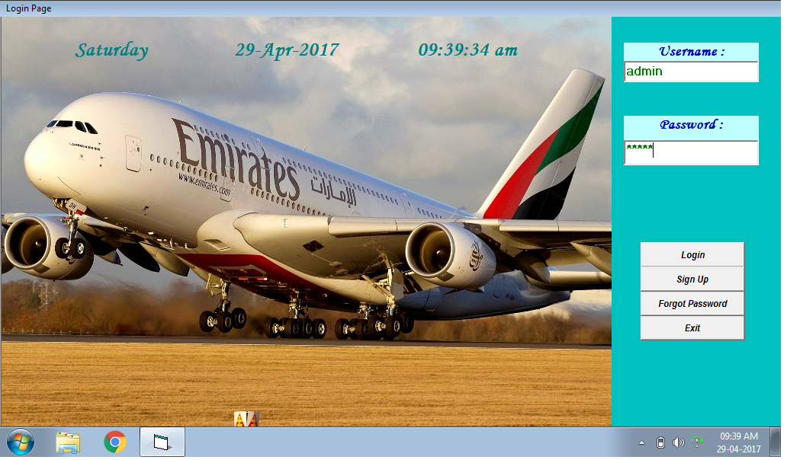

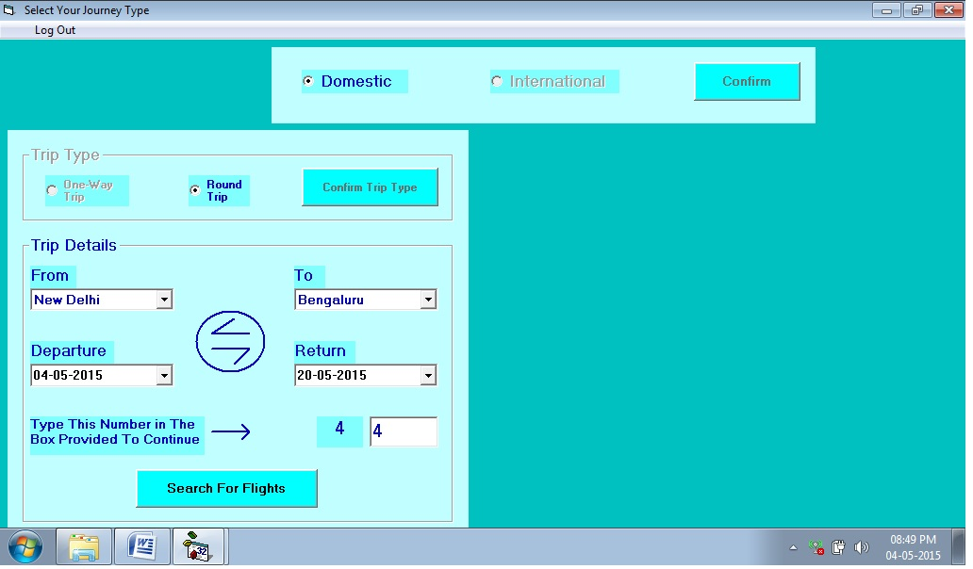

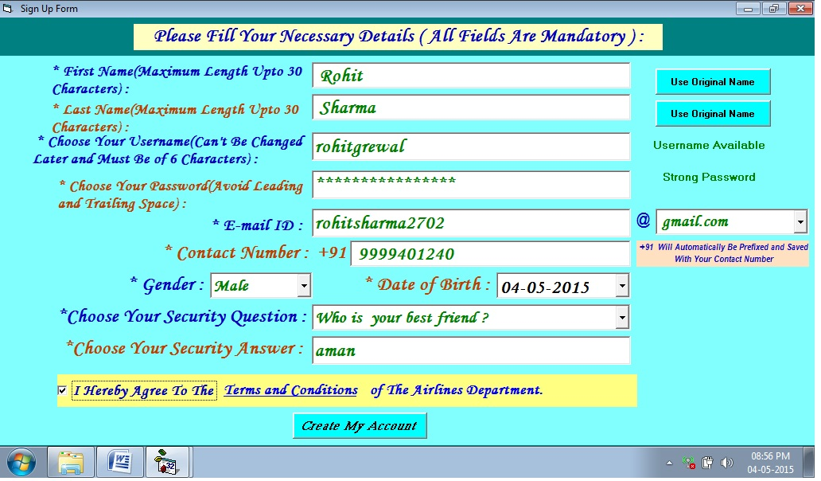

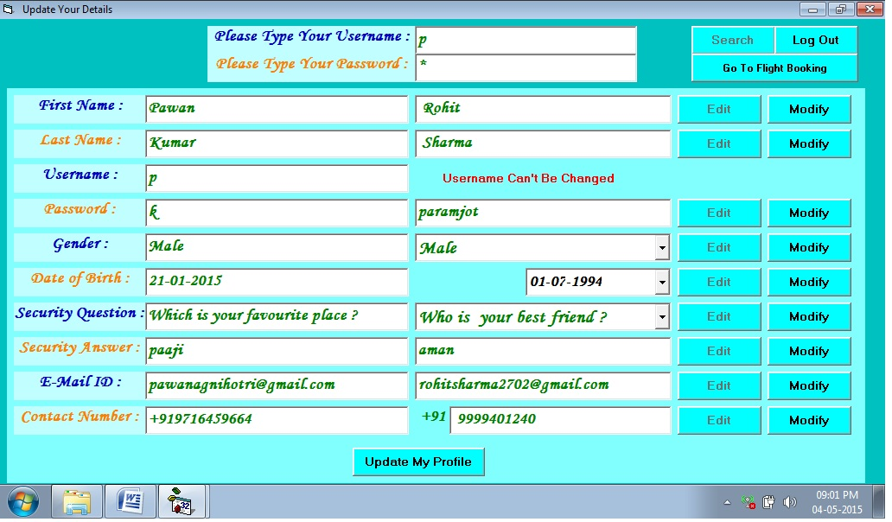
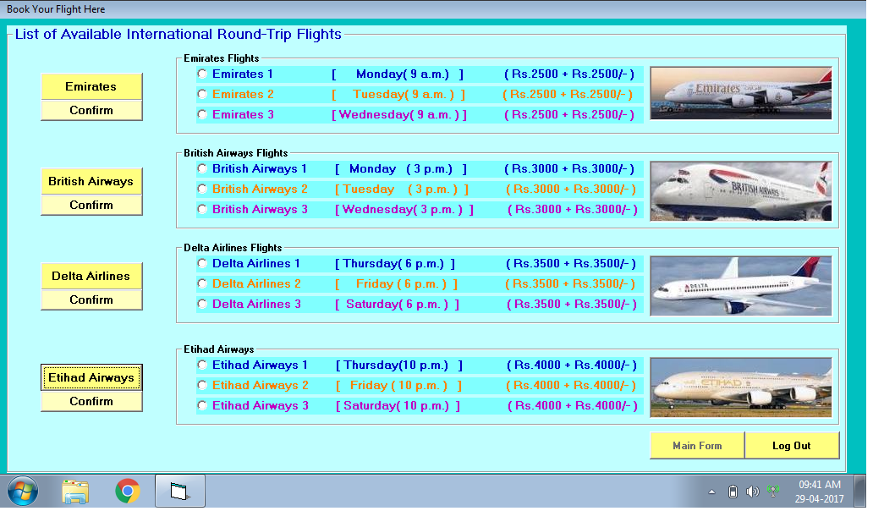

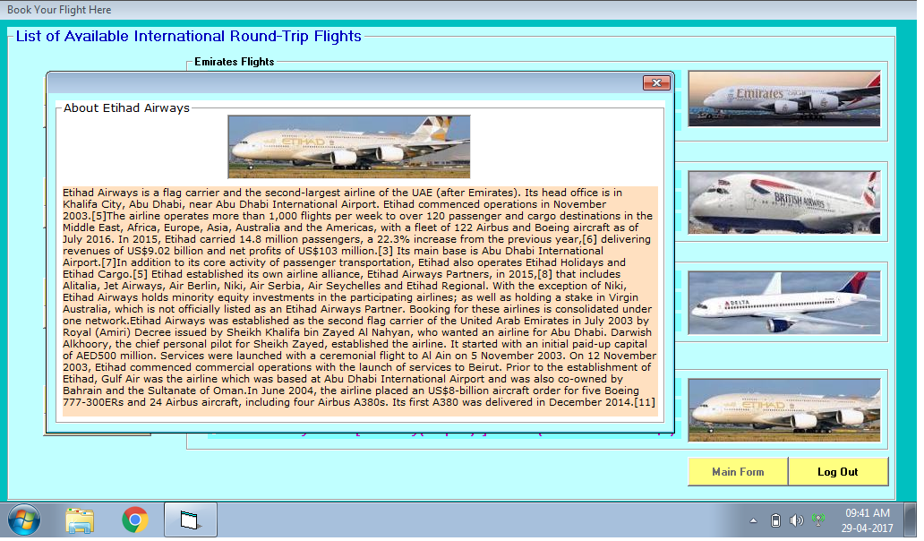
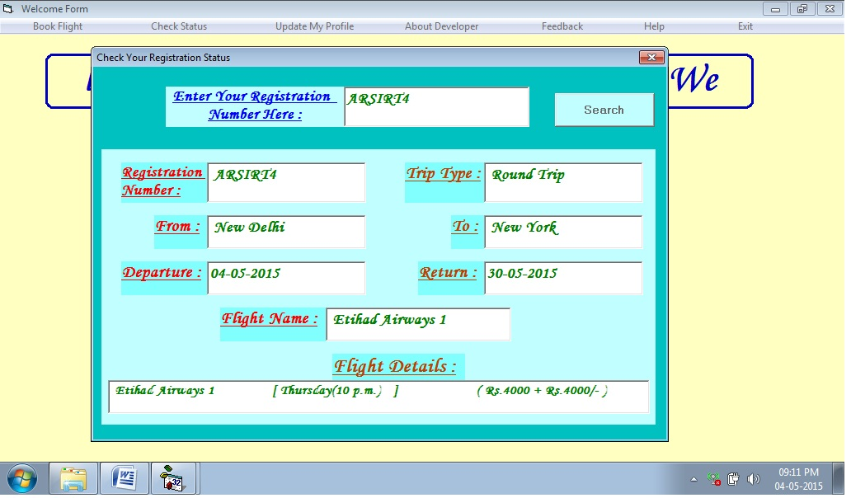

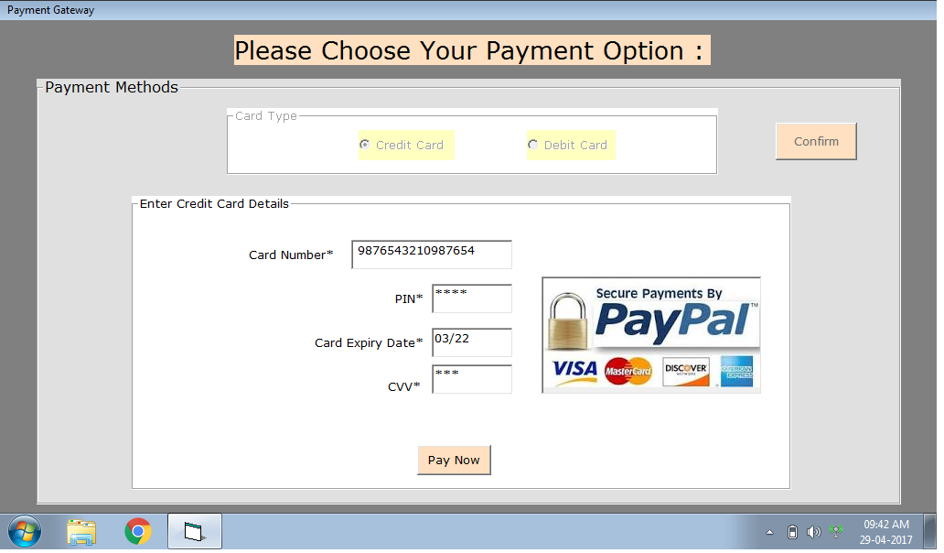
Chapter 4

Testing and Implementation

Implementation is the stage of the project where the theoretical design is turned into a working system. It can be considered to be the most crucial stage in achieving a successful new system gaining the users confidence that the new system will work and will be effective and accurate. It is primarily concerned with user training and documentation. Conversion usually takes place about the same time the user is being trained or later. Implementation simply means convening a new system design into operation, which is the process of converting a new revised system design into an
operational one.
SYSTEM TESTING
Software Testing is the process of executing software in a controlled manner, in order
to answer the question - Does the software behave as specified?. Software testing is often used in association with the terms verification and validation. Validation is the checking or testing of items, includes software, for conformance and consistency with an associated specification. Software testing is just one kind of verification, which also uses techniques such as reviews, analysis, inspections, and walkthroughs. Validation is the process of checking that what has been specified is what the user actually wanted.
Validation: Are we doing the right job?
Verification: Are we doing the job right?
Software testing should not be confused with debugging. Debugging is the process of analyzing and localizing bugs when software does not behave as expected. Although the identification of some bugs will be obvious from playing with the software, a methodical approach to software testing is a much more thorough means for identifying bugs.
Debugging is therefore an activity which supports testing, but cannot replace testing.
Other activities which are often associated with software testing are static analysis and dynamic analysis. Static analysis investigates the source code of software, looking for problems and gathering metrics without actually executing the code. Dynamic analysis looks at the behavior of software while it is executing, to provide information such as execution traces, timing profiles, and test coverage information.
Testing is a set of activity that can be planned in advanced and conducted
systematically. Testing begins at the module level and work towards the integration of entire computers based system. Nothing is complete without testing, as it vital success of the system testing objectives, there are several rules that can serve as testing objectives.
They are
Testing is a process of executing a program with the intend of finding an error. A good test case is one that has high possibility of finding an undiscovered error. A successful test is one that uncovers an undiscovered error.
If a testing is conducted successfully according to the objectives as stated above, it
would uncovered errors in the software also testing demonstrate that the software
function appear to be working according to the specification, that performance
requirement appear to have been met.
There are three ways to test program.
• For correctness
• For implementation efficiency
• For computational complexity
Test for correctness are supposed to verify that a program does exactly what it was
designed to do. This is much more difficult than it may at first appear, especially for large
programs.

TEST PLAN
A test plan implies a series of desired course of action to be followed inaccomplishing various testing methods. The Test Plan acts as a blue print for the action that is to be followed. The software engineers create a computer program, its documentation and related data structures. The software developers is always responsible for testing the individual units of the programs, ensuring that each performs the function for which it was designed. There is an independent test group (ITG) which is to remove the inherent problems associated with letting the builder to test the thing that has been built. The specific objectives of testing should be stated in measurable terms. So that the mean time to failure, the cost to find and fix the defects, remaining defect density or frequency ofoccurrence and test work-hours per regression test all should be stated within the test
plan.
The levels of testing include:
• Unit testing
• Integration Testing
• Data validation Testing
• Output Testing

UNIT TESTING
Unit testing focuses verification effort on the smallest unit of software design – the
software component or module. Using the component level design description as a guide, important control paths are tested to uncover errors within the boundary of the module.
The relative complexity of tests and uncovered scope established for unit testing. The unit testing is white-box oriented, and step can be conducted in parallel for multiple components. The modular interface is tested to ensure that information properly flows into and out of the program unit under test. The local data structure is examined to ensure that data stored temporarily maintains its integrity during all steps in an algorithm’s execution. Boundary conditions are tested to ensure that all statements in a module have been executed at least once. Finally, all error handling paths are tested.
Tests of data flow across a module interface are required before any other test is
initiated. If data do not enter and exit properly, all other tests are moot. Selective testing of execution paths is an essential task during the unit test. Good design dictates that error conditions be anticipated and error handling paths set up to reroute or cleanly terminate processing when an error does occur. Boundary testing is the last task of unit testing step.
Software often fails at its boundaries.
Unit testing was done in Sell-Soft System by treating each module as separate entity and testing each one of them with a wide spectrum of test inputs. Some flaws in the internal logic of the modules were found and were rectified.

INTEGRATION TESTING
Integration testing is systematic technique for constructing the program structure
while at the same time conducting tests to uncover errors associated with interfacing. The objective is to take unit tested components and build a program structure that has been dictated by design. The entire program is tested as whole. Correction is difficult because isolation of causes is complicated by vast expanse of entire program. Once these error are corrected, new ones appear and the process continues in a seemingly endless loop.
After unit testing in Sell-Soft System all the modules were integrated to test for an inconsistencies in the interfaces. Moreover differences in program structures were
removed and a unique program structure was evolved.

VALIDATION TESTING OR SYSTEM TESTING
This is the final step in testing. In this the entire system was tested as a whole with all forms, code, modules and class modules. This form of testing is popularly known as Black Box testing or System testing.
Black Box testing method focuses on the functional requirements of the software.
That is, Black Box testing enables the software engineer to derive sets of input conditions
that will fully exercise all functional requirements for a program.
Black Box testing attempts to find errors in the following categories; incorrect or
missing functions, interface errors, errors in data structures or external data access,
performance errors and initialization errors and termination errors.
OUTPUT TESTING OR USER ACCEPTANCE TESTING
The system considered is tested for user acceptance; here it should satisfy the firm’s need. The software should keep in touch with perspective system

Implementation

Once the system is successfully developed the next important step is to ensure that the administrators are well trained to handle the system. This is because the success of a system invariably depends on how they are operated and used. The implementation depends upon the right people being at the right place at the right time. Education involves creating the right atmosphere and motivating the user. The administrators are familiarized with the run procedures of the system, working through the sequence of activities on an ongoing basis.
Implementation is the state in the project where the theoretical design is turned into a working system. By this, the users get the confidence that the system will work
effectively. The system can be implemented only after through testing.
The systems personnel check the feasibility of the system. The actual data were
inputted to the system and the working of the system was closely monitored. The master option was selected from the main menu and the actual data were input through the corresponding input screens. The data movement was studied and found to be correct queries option was then selected and this contains various reports. Utilities provide various data needed for inventory was input and the module was test run. Satisfactory results were obtained. Reports related to these processes were also successfully generated. Various input screen formats are listed in the appendix.
Implementation walkthroughs ensure that the completed system actually solves the
original problem. This walkthrough occurs just before the system goes into use, and it should include careful review of all manuals, training materials and system
documentation. Again, users, the analyst and the members of the computer services staff may attend this meeting.

References

- Programming in VB 6.0 By Tata McGraw Hills
- Advance MS-Office by Andrew McGrath

Online Reference

www.google.com
www.youtube.com

